|  |  |
| --- | --- |
| A) | B) |
| C) | D) |
| Figure 1: **Validation of model** | |

|  |  |
| --- | --- |
| A) | B) |
| Figure 2**: Estimated prevalence of AEP** | |

|  |  |
| --- | --- |
| A) |  |
| Figure 3: **You only need to visualize the left-hand side figure but it should look like the one on the right-hand side (which shows two fitted linear line along with their corresponding prediction intervals).** | |

|  |
| --- |
|  |
| Figure 4: **This figure is a little bit tricky! it’s two figures that I want to combine into one (or not if you think it’s a bad idea!). Let’s discuss.** |

|  |  |
| --- | --- |
| A) | B) |
| C) | D) |
| Figure 5**: Additional figures** | |

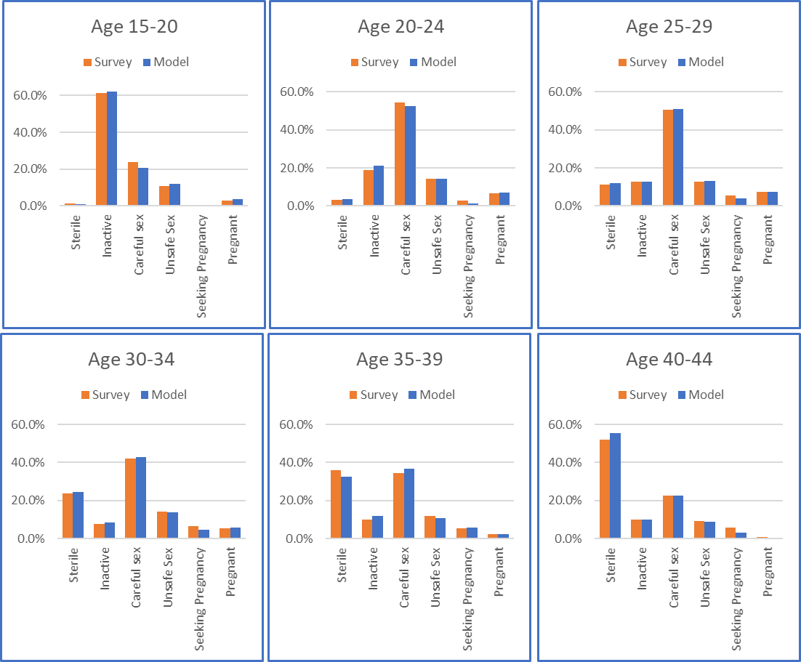

Figure 6**: Distribution of population members in age and sexual-behavior groups**